**Assignment 4**

1. Write an Assembly Language Program to add 3 X 3 matrices. Assume the matrices

are stored in the form of lists (row wise). First matrix is stored from DS:0030H and

the second matrix is stored from DS:0040.Store the result of the addition in the third

lists starting from DS:0050H.

**Code**

.model small

.stack 100h

.data

.code

main proc

mov ax, @data

mov ds, ax

;mov es, ax

mov si, 0030h

mov bx, 0040h

mov di, 0050h

mov cx, 0009h

l1:

mov al, [si]

add al, [bx]

mov [di], al

inc di

inc si

inc bx

loop l1

int 03h

mov ah, 4ch

int 21h

main endp

end main

**Output**

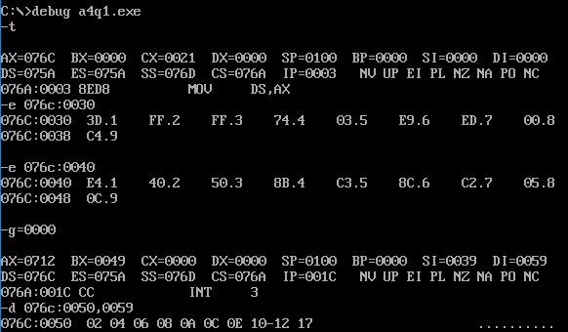

1. Write an Assembly Language Program to convert an eight bit binary number stored in

DS:0030H into its equivalent BCD number. Stored the result in DS:0040H.

**Code**

.model small

.stack 100h

.data

.code

main proc

mov ax, @data

mov ds, ax

mov si, 0030h

mov bl, [si]

mov ax, 0000h

mov dx, 0000h

cmp bl, 00h

jz l2

l1:

add ax, 01h

daa

adc dl, 00h

dec bl

cmp bl, 00h

jnz l1

l2: mov si, 0040h

mov [si], dl

inc si

mov [si], ax

int 03h

mov ah, 4ch

int 21h

main endp

end main

**Output:**

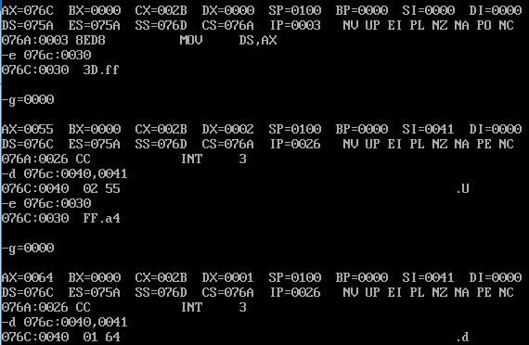

1. Write an Assembly program to convert a BCD number stored in DS:0030H into its

equivalent hexadecimal number. Stored the result in DS:0040H.

**Code:**

.model small

.stack 100h

.data

.code

main proc

mov ax, @data

mov ds, ax

mov si, 0030h

mov al, [si]

mov bl, 00h

cmp al, 00h

jz l2

l1: sub al, 01h

das

inc bl

cmp al, 00h

jz l2

jmp l1

l2: mov si, 0040h

mov [si], bl

int 03h

mov ah, 4ch

int 21h

main endp

end main

**Output:**

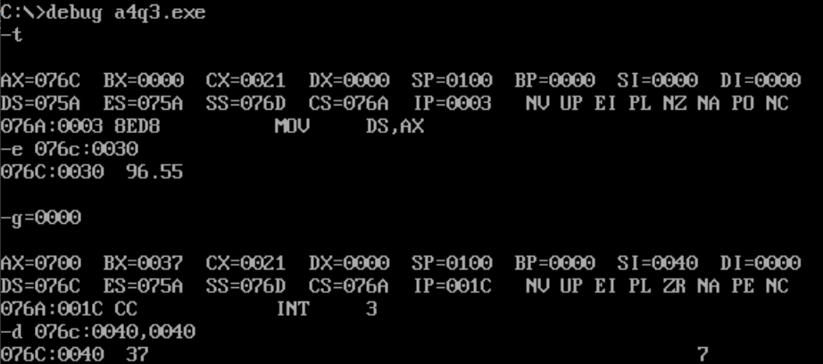

1. Write an Assembly program to convert a binary number stored in DS:0030H into its equivalent gray code. Stored the result in DS:0040H.

**Code:**

.model small

.stack 100h

.data

.code

main proc

mov ax, @data

mov ds, ax

mov si, 0030h

mov al, [si]

mov bl, al

ror bl, 01h

xor al, bl

mov si, 0040h

mov [si], al

int 03h

mov ah, 4ch

int 21h

main endp

end main

**Output:**

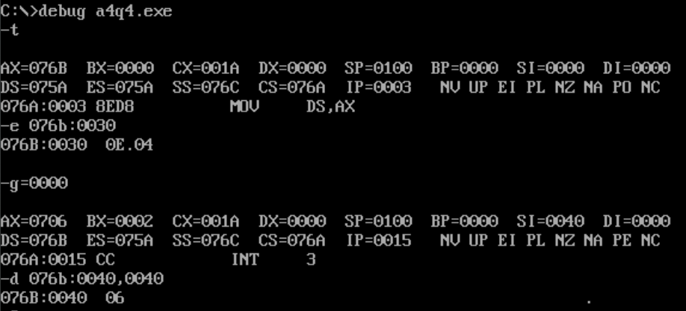

1. Write an Assembly program to find the factorial of a number stored in DS:0030H.

Store the result in DS:0040H.

**Code:**

.model small

.stack 100h

.data

.code

main proc

mov ax, @data

mov ds, ax

mov si, 0030h

mov bl, [si]

mov bh, 00h

mov ax, 0001h

cmp bl, 00h

jz l2

cmp bl, 01h

jz l2

l1:

mul bx

dec bl

cmp bl, 01h

jz l2

jmp l1

l2: mov si, 0040h

mov [si], dh

inc si

mov [si], dl

inc si

mov [si], ah

inc si

mov [si], al

int 03h

mov ah, 4ch

int 21h

main endp

end main

**Output:**

